Apocalypse Preview: New Pain Lands
Zvi Mowshowitz
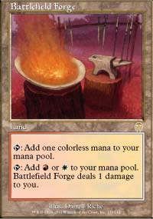
Battlefield Forge, Caves of Koilos, Llanowar Wastes, Shivan Reef and Yavimaya Coast - the opposite color pain lands. We've been waiting for them since Ice Age. Before Apocalypse, whenever anyone wanted to build a deck with opposite colors they had no good options for solidifying their mana base. The last attempt at opposite-colored dual lands came into play tapped, and they were still worth using. Since then, the only choice has been to overpay for a tricolor or five-color land.
Those options were still better than running only basic lands. Rishadan Port makes things even worse, both the need to deal with opposing ones and the need to play them if the deck calls for them. At that point, the available options were City of Brass and recently the Lairs from Planeshift, unless the deck's main color was green. City of Brass has a big Rishadan Port problem and basically forces someone who wants access to two or three colors of mana to take a disadvantage large enough to give him all five. After that are marginal tricks like Chromatic Sphere. Adding a third color doesn't make the problem any easier, but if it's the color allied to the other two, then the combination of free pain lands and Invasion tapped lands and Planeshift Lairs makes it possible to make that third color relatively inexpensive to use.
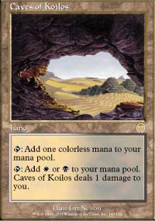
A two-color deck that isn't too controlling (say it's white-black) might use two City of Brass and three Dromar's Cavern along with twenty basic lands. The same deck splashing in blue so it can use Lobotomy and Dromar's Charm might then use four Adarkar Wastes, four Underground River - it now has more than enough blue mana without giving up much more than a little damage. Often that meant that there was no good reason not to do it, even with little worth using. How much pain is really involved in playing these lands en masse? The great advantage is that if only colorless mana is needed, there is no cost involved in the use of pain lands, so they're ideal for decks that want consistent access to colors for key spells but don't need that color continuously. Then again, for decks that do need that mana many times, playing with pain lands to get good mana can cause serious issues.
In Invasion Block, the problem was even more acute, especially with the need to use a lot of multi-colored cards. Domain decks naturally want to use basic lands in order to have the Domain in play, but the other top decks suffered due to the lack of these lands. Red-green may not seem to care at all, but it could splash either white or black for fun and profit. With white it gets mirror matchup cards like Rith, the Awakener and Armadillo Cloak, and with black it can play good stuff like Blazing Specter or maindeck Thunderscape Battlemage to fight enchantments. By far the hardest fit however was GoMar. It plays three allied colors, and by far its biggest problem is finding its mana. If GoMar's mana draw is good, the deck is clearly the best in the format, but the deck is so color intensive that with only eight dual lands, Domain probably has the better mana base even though it uses all five colors. When it can utilize four copies of the white-black pain land Caves of Koilos, things will get a lot better.
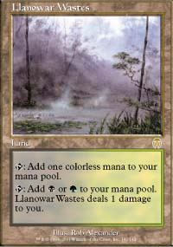
In block, these new dual lands make the mana of decks with opposite colors better than the mana of decks with allied colors. They are simply better cards than the dual lands that come into play tapped, although both are definitely worth playing. Such decks now have much better mana bases, and the rest of Apocalypse gives them much better spells as well. Much more interesting however is the ability to play three non-allied colors. With twelve good dual lands available, these decks have better mana bases than something like GoMar used to. They can average about twelve sources per color, so if one is a splash than things are very reasonable.
In Standard, these new pain lands basically generate a free for all. At Pro Tour-Chicago, the commonly played decks lined up perfectly with the allied colors: White-blue gave Counterrebels and w-u Control, u-b became Nether-Go and similar strategies, r-b became Machinehead, r-g was Fires of Yavimaya and w-g was bad but still tried. Together with mono-color decks, Skies and Rebels that was basically the entire format. Other deck ideas were interesting, but lacked the kind of mana base they needed. The most prominent was r-u, normally in the form of Counterhammer. This deck had problems dealing with any kind of permanents that couldn't be burned out if they hit the table, but had definite advantages. What sunk it was that with a maximum of around twenty-six mana sources, the deck couldn't support both Counterspell and Hammer of Bogardan. The one deck that came close to crossing the color barrier was "Burning Skies", a Skies decks using some burn, but they sunk as well - Foil and Thwart were too hard to use even if the color was workable if not quite acceptable.
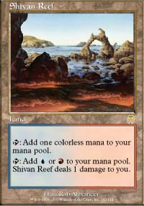
Hammer itself is gone now, but Counter-Burn is one strategy that now has a lot more going for it. Red-blue decks may well pop up, based on combining a blue base with red removal. Red-white decks can use a few new cards to support what will probably be essentially burning rebel decks or counterless control decks. Will we see the return of the Burning Bridge? Even better, can this kind of deck then use the new dual lands to effortlessly splash blue and get the counters it desperately needs? White-black got a huge boost with cards like Vindicate to go with its new mana. It will probably take a controlling "good stuff" form of some sort, and can splash any third color it needs. One likely candidate to merge with is green-black, which gets an exciting new creature. It wouldn't be at all suprising to see this deck as the new Fires whether it keeps the red or not.
One other thing that might happen is w-u decks splashing red for Urza's Rage to win long games automatically if the pain doesn't hurt too much. For a long time, these decks have been looking for a good kill card, and finally they have an alternative to using creatures or Millstones. Right now, I happen to like Millstone, but more often it's a poor choice. Stuff like that is now not just viable. In turn, it makes Standard and Block much less predictable and gives them many more viable deck types.
With all the new dual lands, a deck can now run no basic lands or almost no basic lands. This creates both opportunities and problems. A white-blue deck could realistically now think about splashing red to cast Boil, but on the other hand so could everyone else so there's not as much point as there once would have been. Still, Foil and Thwart and the general dislike of taking needless damage will keep Islands in circulation, so it will be interesting to see how many blue decks start showing up packing Boils. 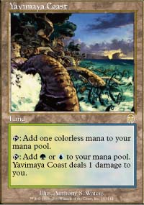
Then there's the other side, which is punishing players for overusing nonbasic lands. The obvious instrument of vengence is Dust Bowl, but it's been seriously crippled by Tsabo's Web. Still, it's easy to see decks that pack cards like Thornscape Battlemage to kill Webs and then finish people off with 3-4 Dust Bowls. Not using enough basics can be very dangerous. Decks might even start going for Global Ruin if it reduces even three color decks to one land. Maybe it's for the best that the truly devastating weapons like Back to Basics and Price of Progress aren't currently available. Consistent reliable mana may not be a God-given right, but it definitely makes for more interesting Magic.

